PROJECT REPORT

TITLE: MEDICAL STOCK MANAGEMENT SYSTEM

Group Members:

Prateek Ravindra Deshmukh(A20399898)

Vighnesh Sanjay Sawant(A20399823)

Table of Contents:

|  |  |  |
| --- | --- | --- |
| **Sr No** | **Topic** | **Page No** |
| *1* | *Aim of Project* | *3* |
| *2* | *Description of Project* | *3* |
| *3* | *Project Scope* | *3* |
| *4* | *Classes Used* | *4* |
| *5* | *Login Credentials* | *4* |
| *6* | *Execution Steps* | *5* |
| *7* | *Individual Role in Project* | *5* |
| *8* | *ERD* | *6* |
| *9* | *Use Case Diagram* | *7* |
| *10* | *Screenshots(Demo)* | *8* |
| *11* | *Validations* | *20* |

Aim:

Develop a medical stock management system using JavaFX to reduce complexities for medical store. This Software helps them to perform stock management of medicines in medical store.

Description of Project:

The Medical Stock Management System stores all the information/ details of Suppliers, Medicines and gives it to update, delete, search to the data in existing records.

At present Medical stores maintain their day to day transactions of stocks manually. These medical stores have thousands of products, they need to track all these products to check the stock, expiry date etc., If they do not return the expiry products to the distributor in time then they lose that much amount. So, it is very essential to track expiry items prior one month or before, then only they can be able to return these products back. To find the product is also another risky job. So proper system is required. They need a full pledged software to maintain their day to day transactions.

Our software helps them to maintain day to day transactions of stock of medicines in computer. They can keep track of their purchases, stocks details. The software is provided with all the master entries to enter any new product, or supplier to add or modify and delete, search.

Project Scope:

As this is generic software it can be used by a wide variety of outlets (Retailers and Wholesalers) to automate the process of manually maintaining the records related to the subject of maintaining the stock. The main goal of the application is to maintain the records of purchase medicines and stock details & maintenance. This system will cover the following issues Add information of new Suppliers, Medicines. Search information of existing Suppliers, Medicines. Update information of existing Suppliers, Medicines. Delete information of existing Suppliers, Medicines. List the details of existing Supplier, Medicines. Generate daily purchase report.

This application can be accessed by two different kinds of users

* Administrator (Admin)
* Medical Store Manager

Administrator has a control over the different Medical store managers i.e. he/she can add different Medical Store Managers. Also, the administrator can access or generate the daily purchase report of medicines of each medical store.

The medical Store Manager will add new medicine / delete an existing medicine / search for an existing medicine / update an existing medicine and list or view the existing stock of medicine he / she has in his / her store and can add, search, remove a supplier.

Main menu for Medical Stock Management System

The Supplier consists of the following

* Add new Supplier
* Delete supplier
* Search supplier
* Update supplier
* List of suppliers

The Medicine consists of the following

* Add new medicine
* Delete medicine
* Update medicine
* Search medicine
* List of medicine

Classes Used:

* Users:

Users login functionality is added in this class.

* Admin:
* Admin can add different store managers
* Admin can generate daily purchase report
* Admin can also generate supplier wise report
* Store Manager:
* A store manager can add, view, update, delete medicines
* A store manager can add, view, update, delete Suppliers.
* Daily Purchase Report:

This will generate report of medicines by date, so that admin (store owner) can keep track of all stock of medicines for a store manager.

* Supplier Wise Report:

This will generate report of suppliers by name, so that admin (store owner) can keep track of medicines provided by a supplier.

Login Credentials:

* Admin Login:
* Username: admin
* Password: 123
* Store Manager Login:
* Username: pdeshmukh
* Password: pdeshmukh

(We can add as many store managers we want from admin Login).

Execution Steps:

* Double click on the jar file created: “pdesh_finalProj.jar”

OR

* Execute in command prompt:

Go to the file location and execute below:

java -jar pdesh_finalProj.jar

Individual Role In project:

Before talking about the individual contribution of the team members (Vighnesh and Prateek), we shall discuss the combine contribution of our both i.e. what all sections of the project or application we did together. We worked together on login page of the application and in the admin login we provided, we added store manager and for the credentials and details of the store manager, we both together created the tables related to admin and store manager in the database.

Now, talking about the individual contribution of members of team, we are in a group of two (Vighnesh and Prateek).

Talking about Prateek’s contribution:

Prateek had developed the medicine module and by that means, Prateek did work on attributes of medicine i.e. he added details about the medicines in which he added add a medicine, search for a medicine, update a medicine, delete a medicine and to view the list of medicine added previously. Prateek also did work on the daily purchase report of medicine in the admin login, where by selecting a date and a store manager, we would be able to generate (display) report on the medicines that were sold out on that date and by that store manager. For this daily purchase report of medicines, Prateek worked on the database where he created every tables related to medicines.

Talking about Vighnesh’s contribution:

Vighnesh had developed the supplier module and by that means, Vighnesh did work on attributes of Supplier i.e. he added details about the supplier in which he added add a supplier, search for a supplier, update a supplier, delete an existing supplier and to view the list of previously added suppliers. Vighnesh also did work on the supplier wise medicine report in the admin login, where by selecting a date and a supplier, we would be able to generate (display) report on the medicines that were sold out by that specified supplier on that specified date. For this supplier wise medicine report, Vighnesh worked on the database where he created every tables related to supplier.

ENTITY RELATION DIAGRAM:

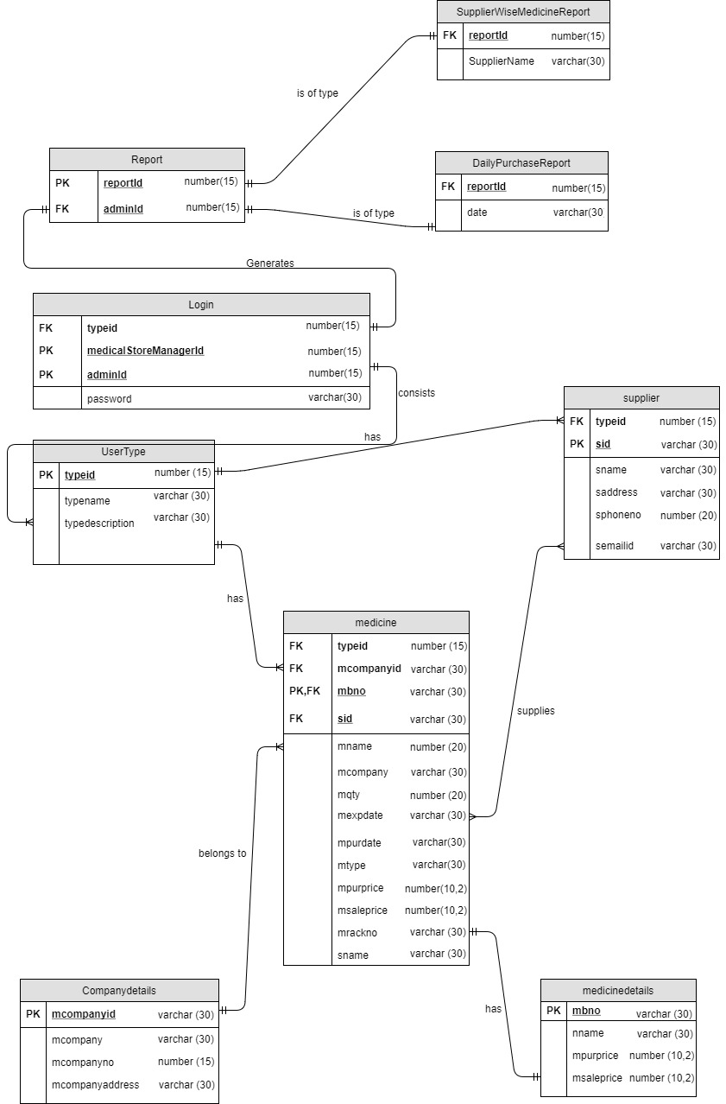

USE CASE DIAGRAM:

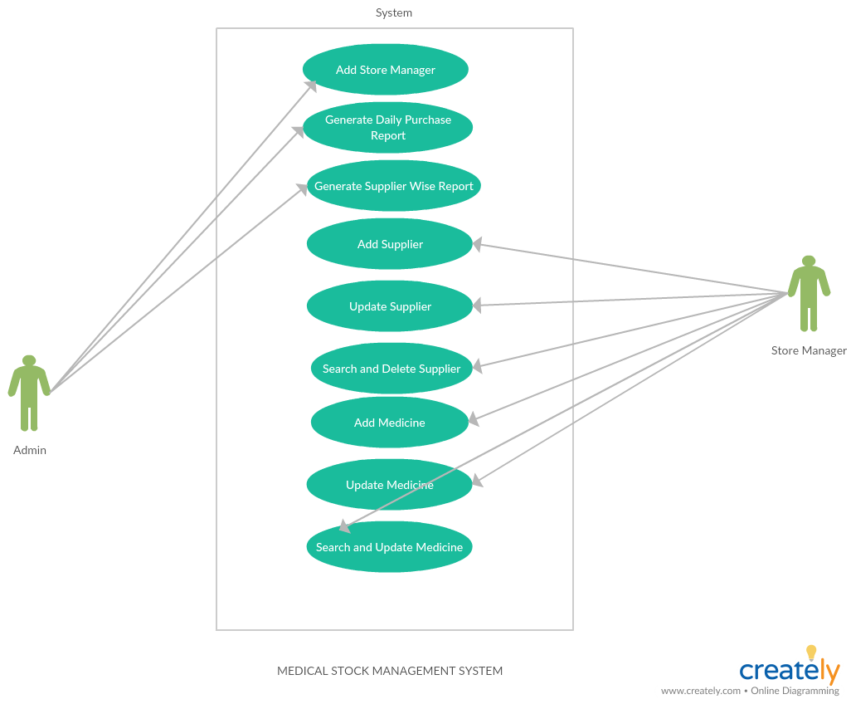

Application Screenshots:

Login Page:

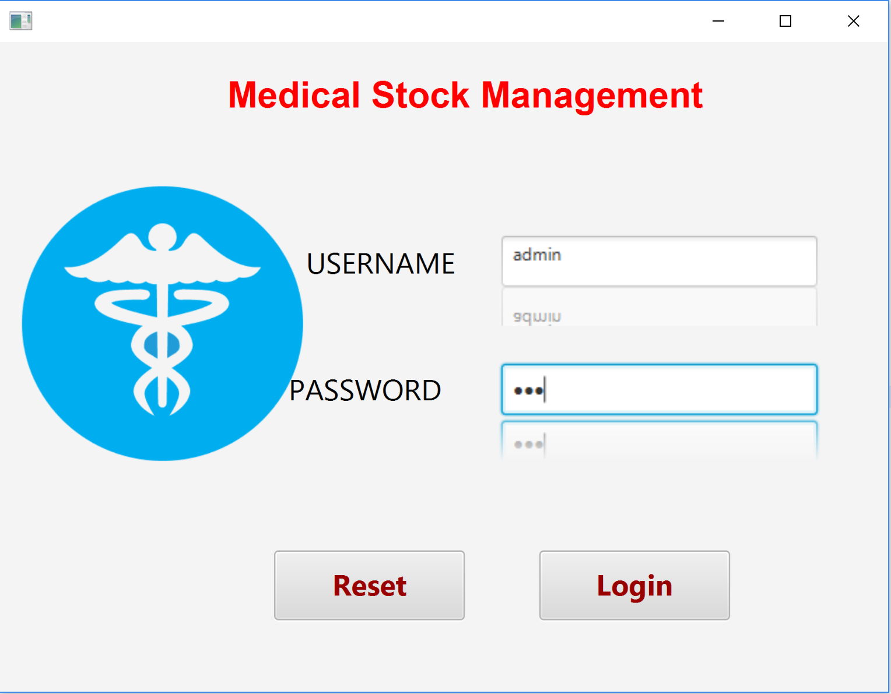

As we have entered admin login details, we will get welcome admin page- The view for Admin.

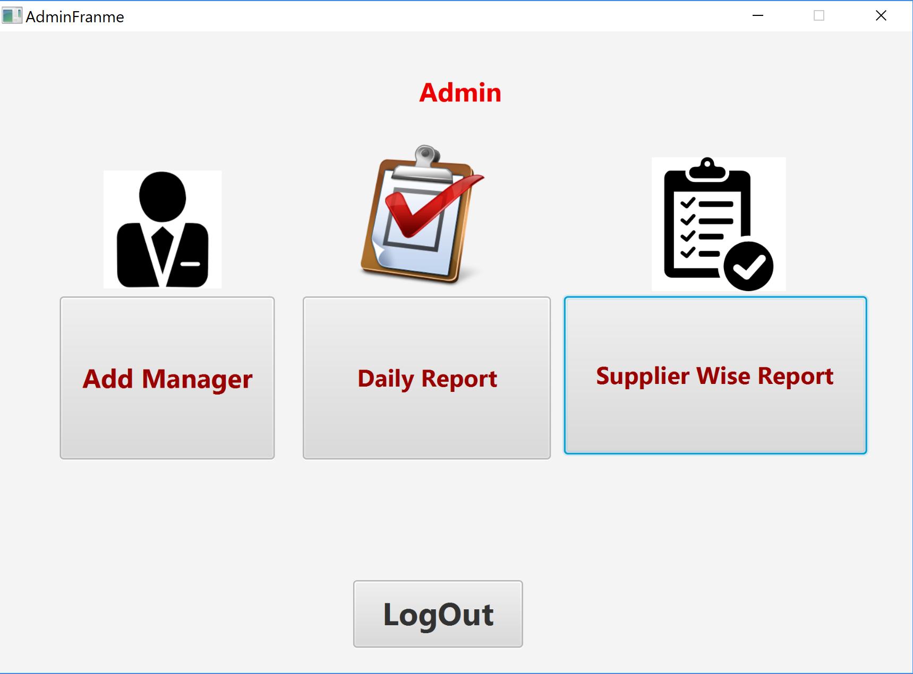

Add Manager: (Prateek has been Successfully inserted into Database)

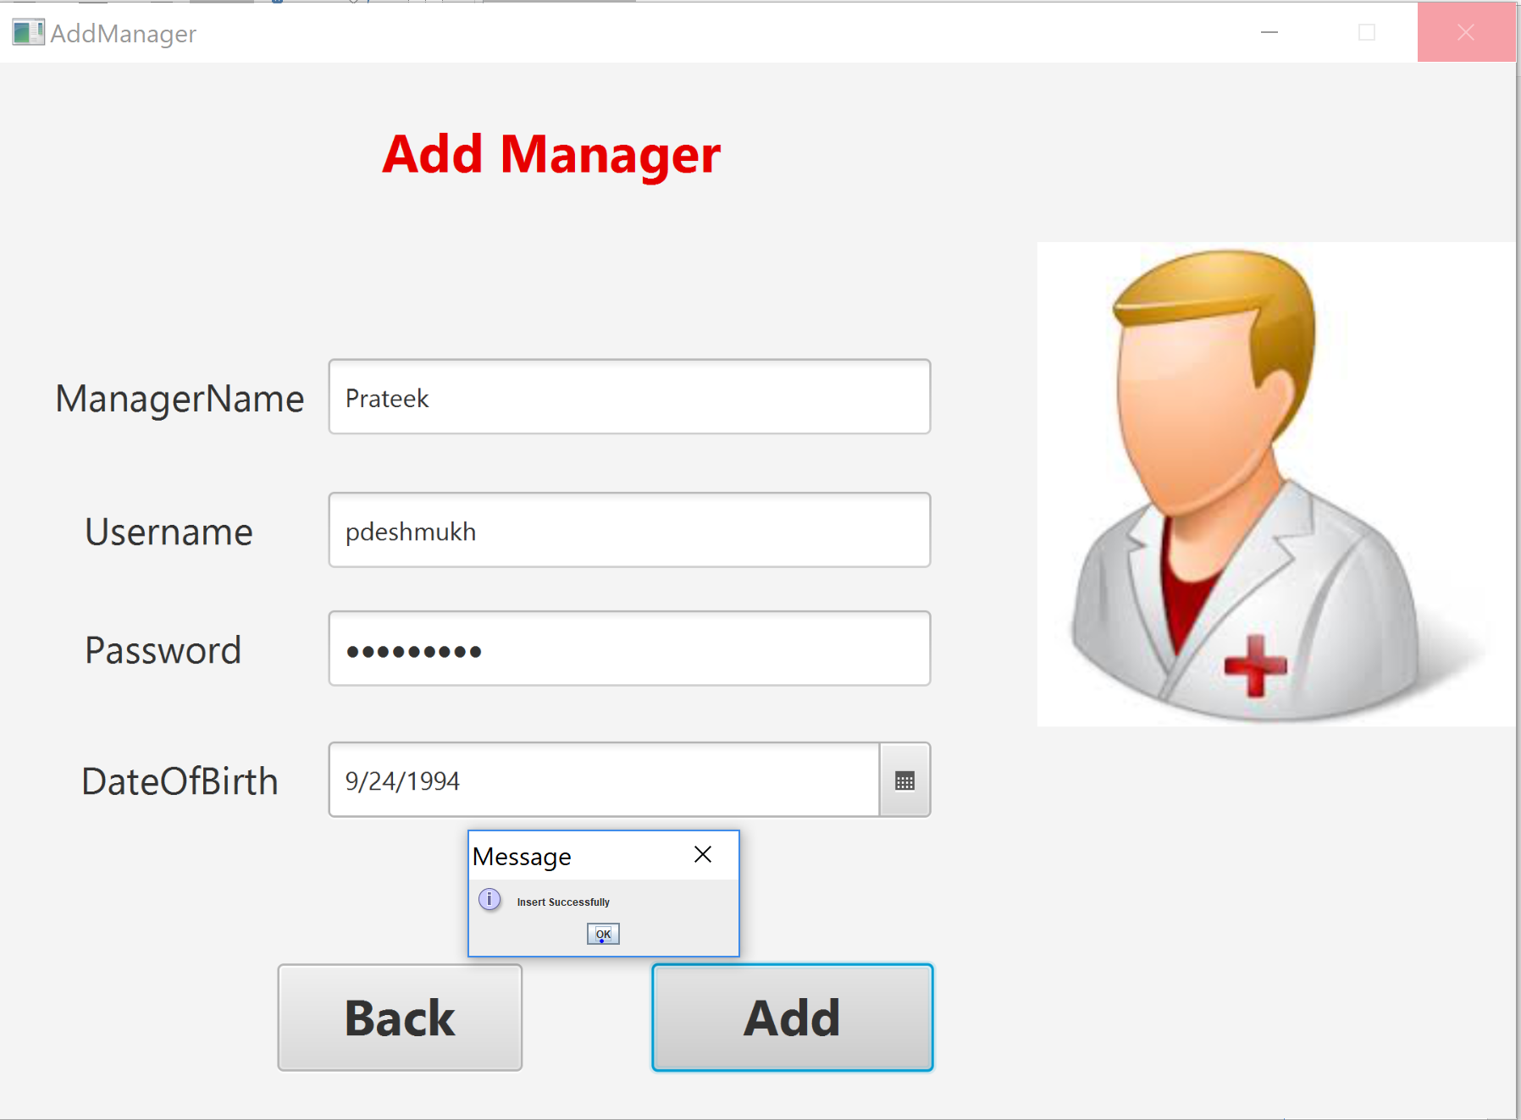

Added Manager:

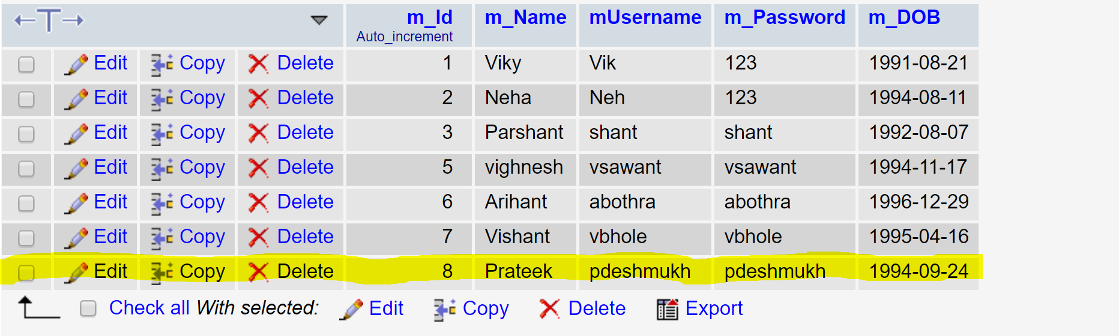

We will come back later to “Daily Purchase Report” and “Supplier Wise Report”

Now lets login with store manager Credentials.

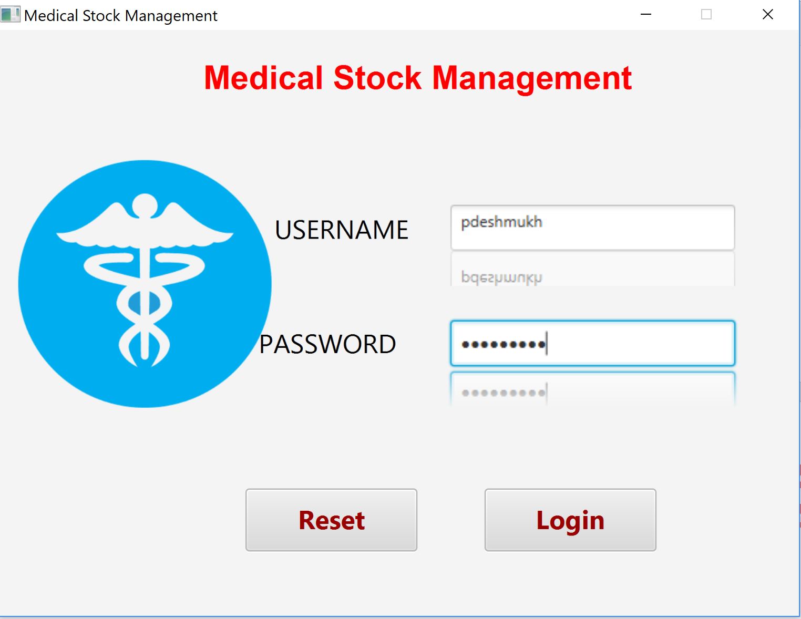

Store Manager View

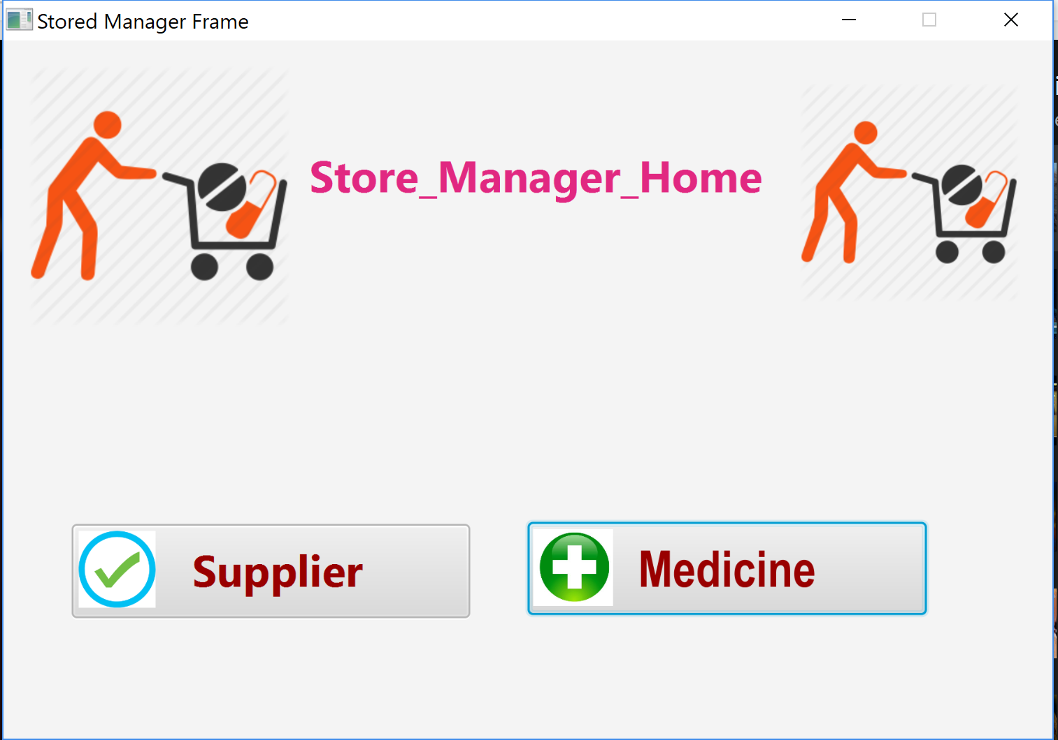

Supplier View

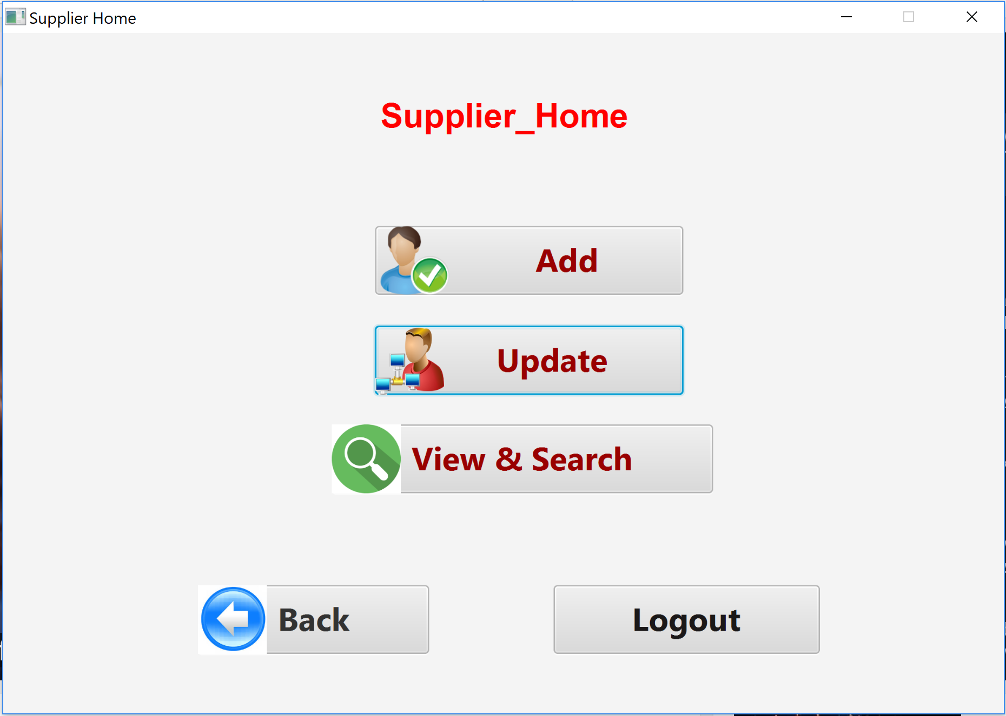

Add Supplier:

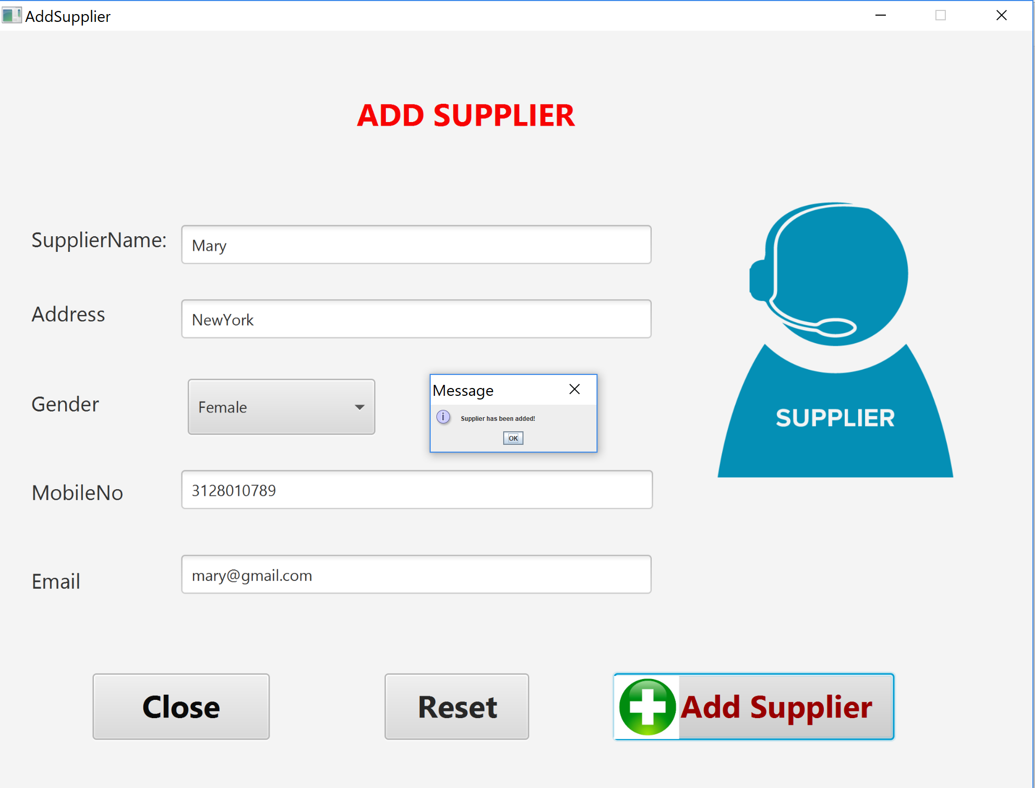

Update Supplier View:

We can update using supplier name(drop down option available to select name)

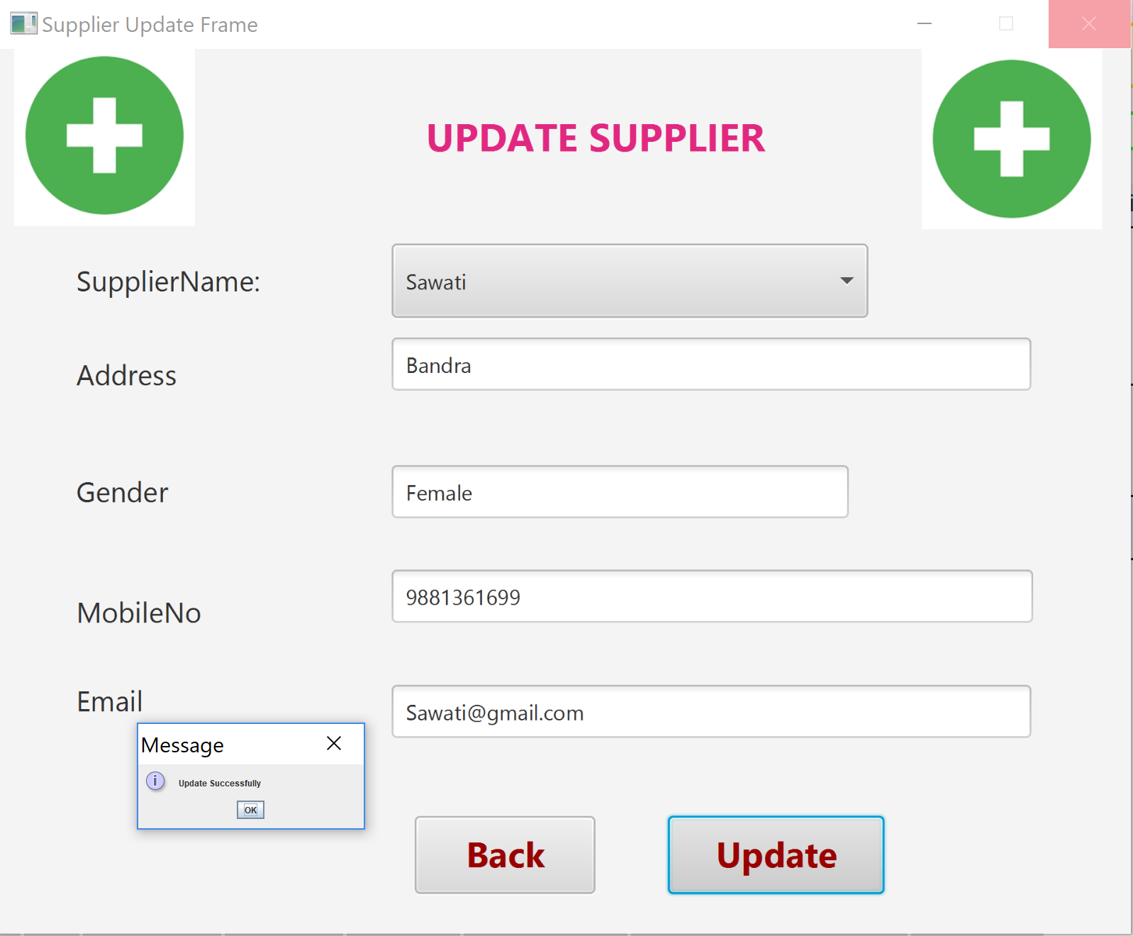

We can see Record is updated.

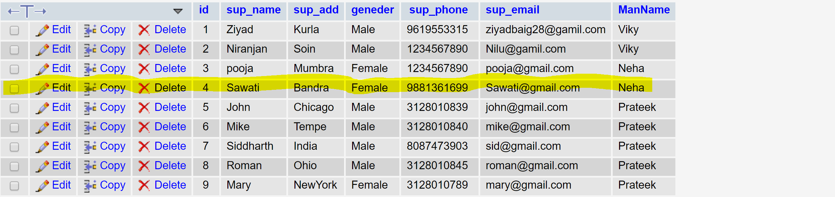

View & Search :

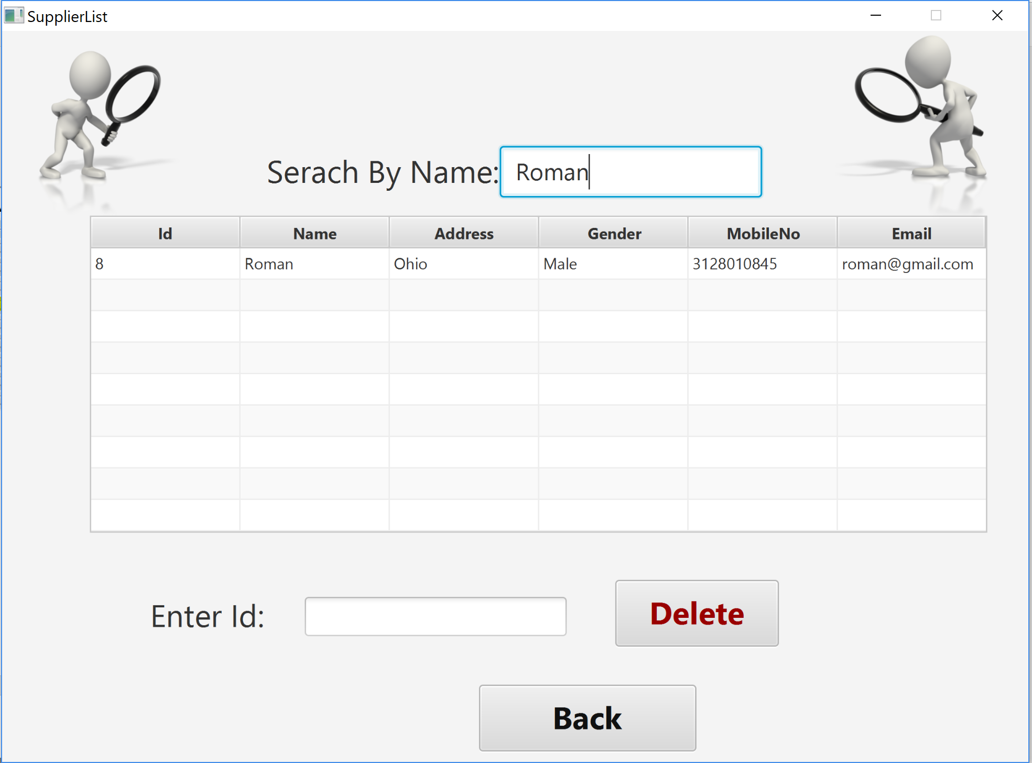

Delete:

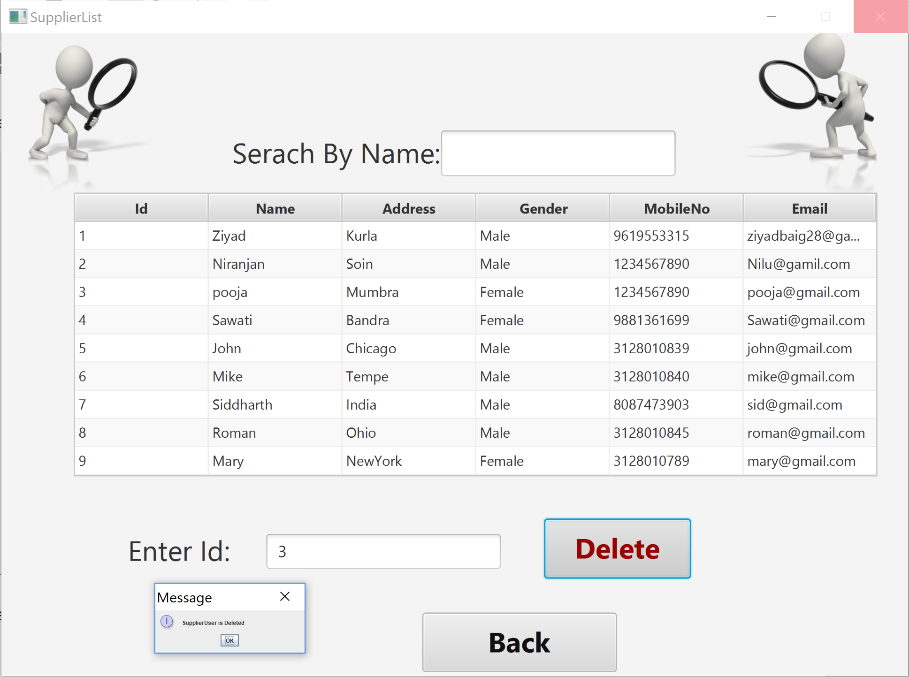

As we can see Supplier Pooja has been deleted.

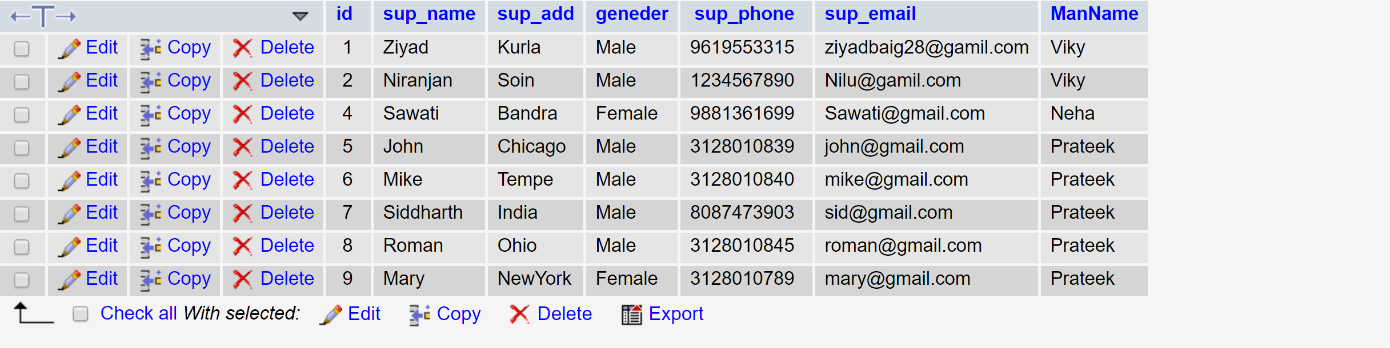

Medicine Home:

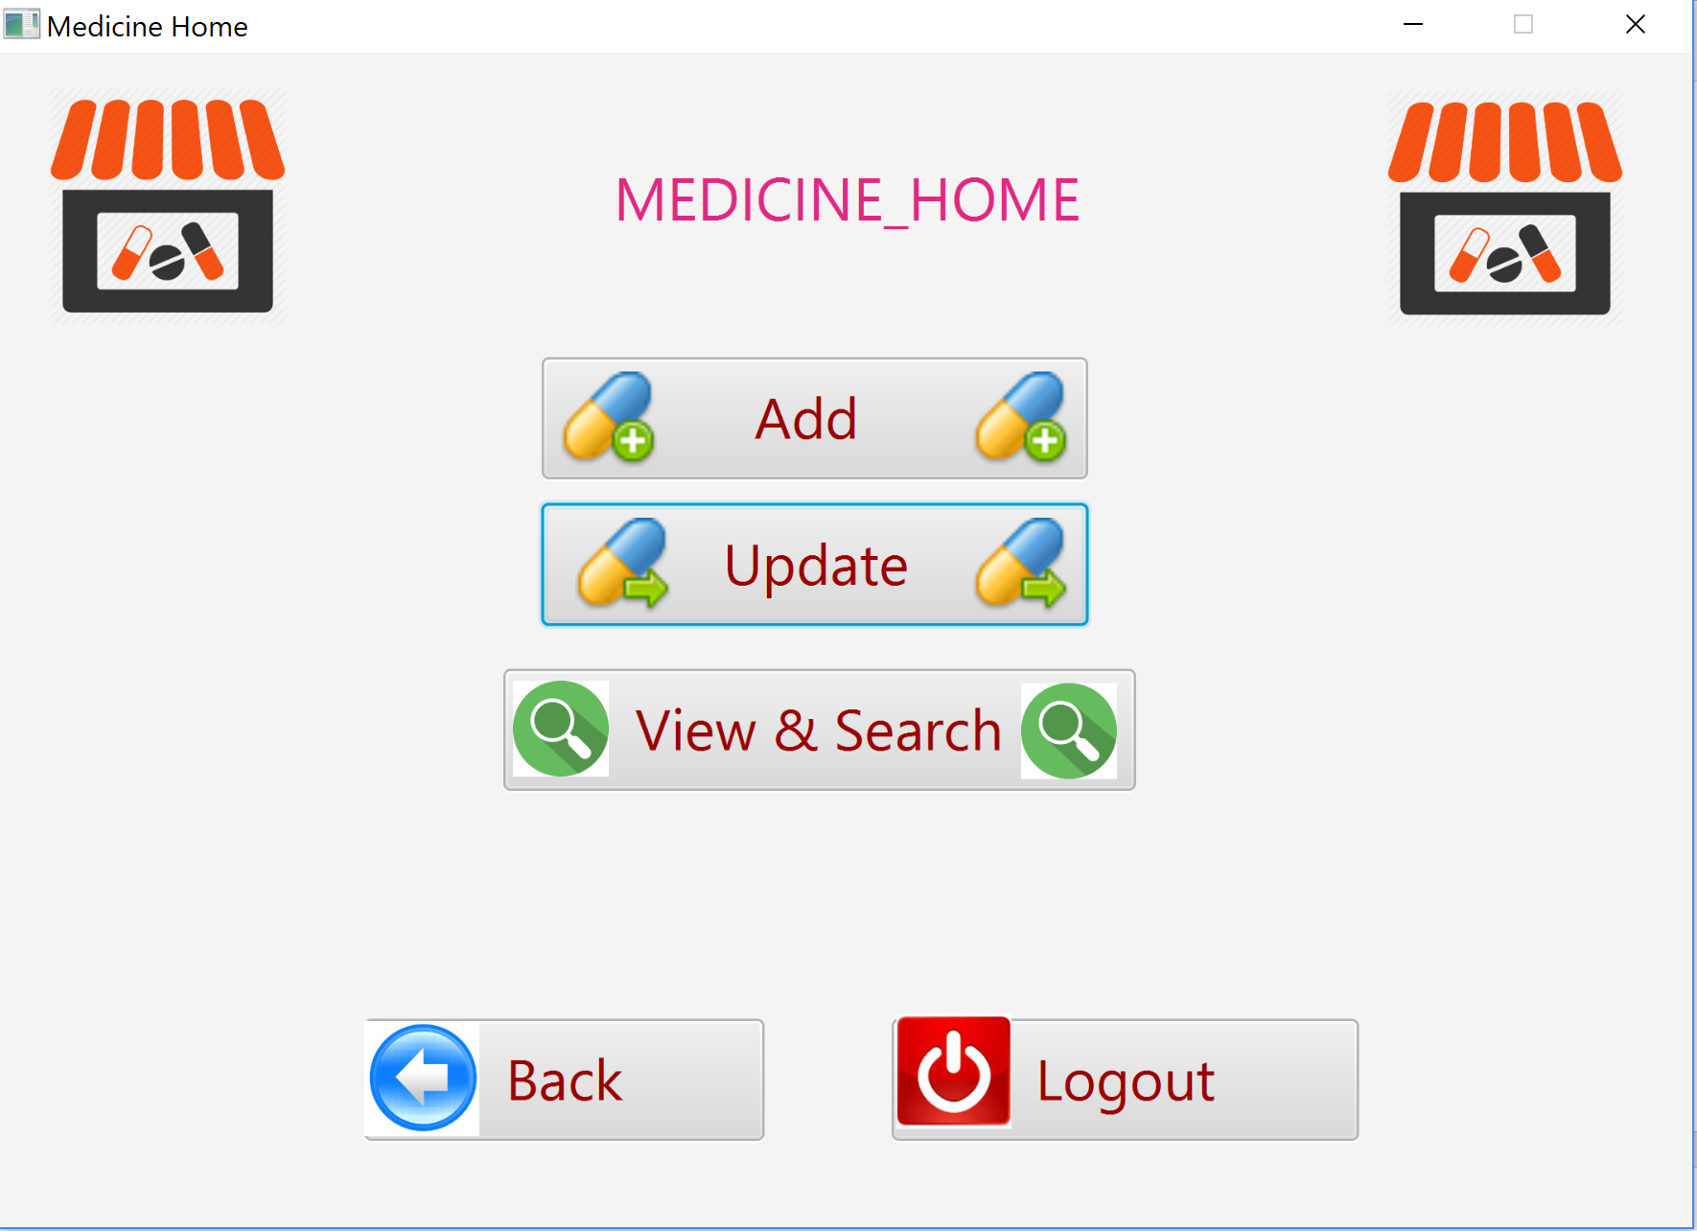

Add Medicine

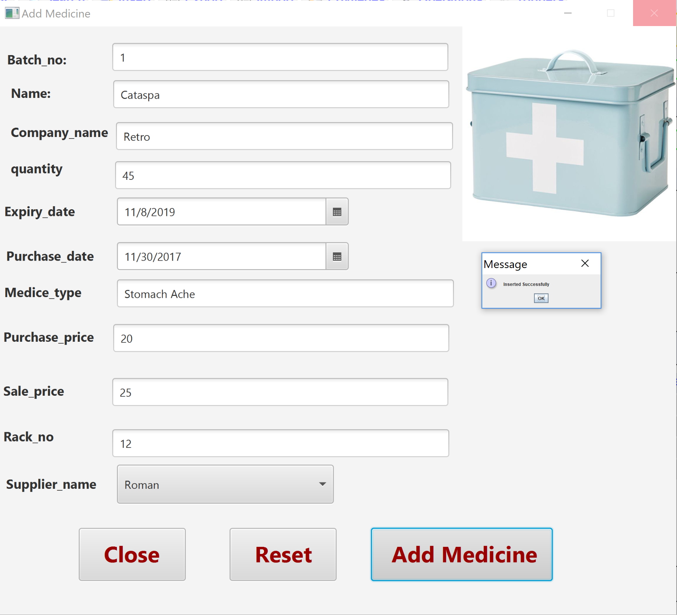

Added into database

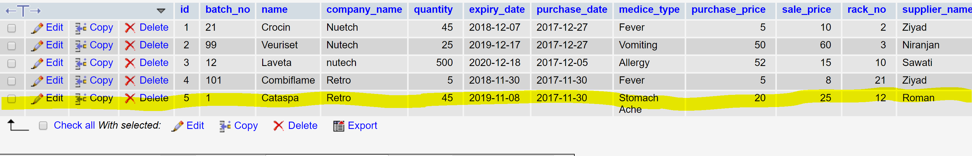

We can Update Medicine By Medicine Name( We can select Name by Drop Down Option)

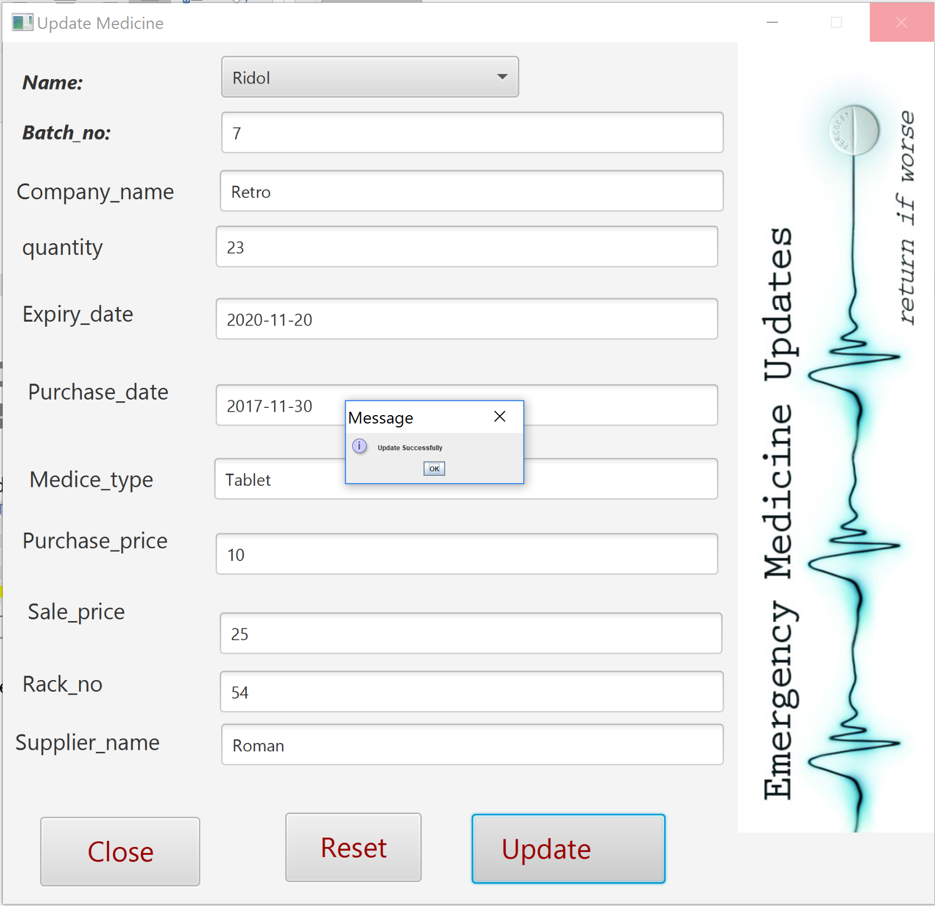

Search Medicine:

We can search by Medicine Name

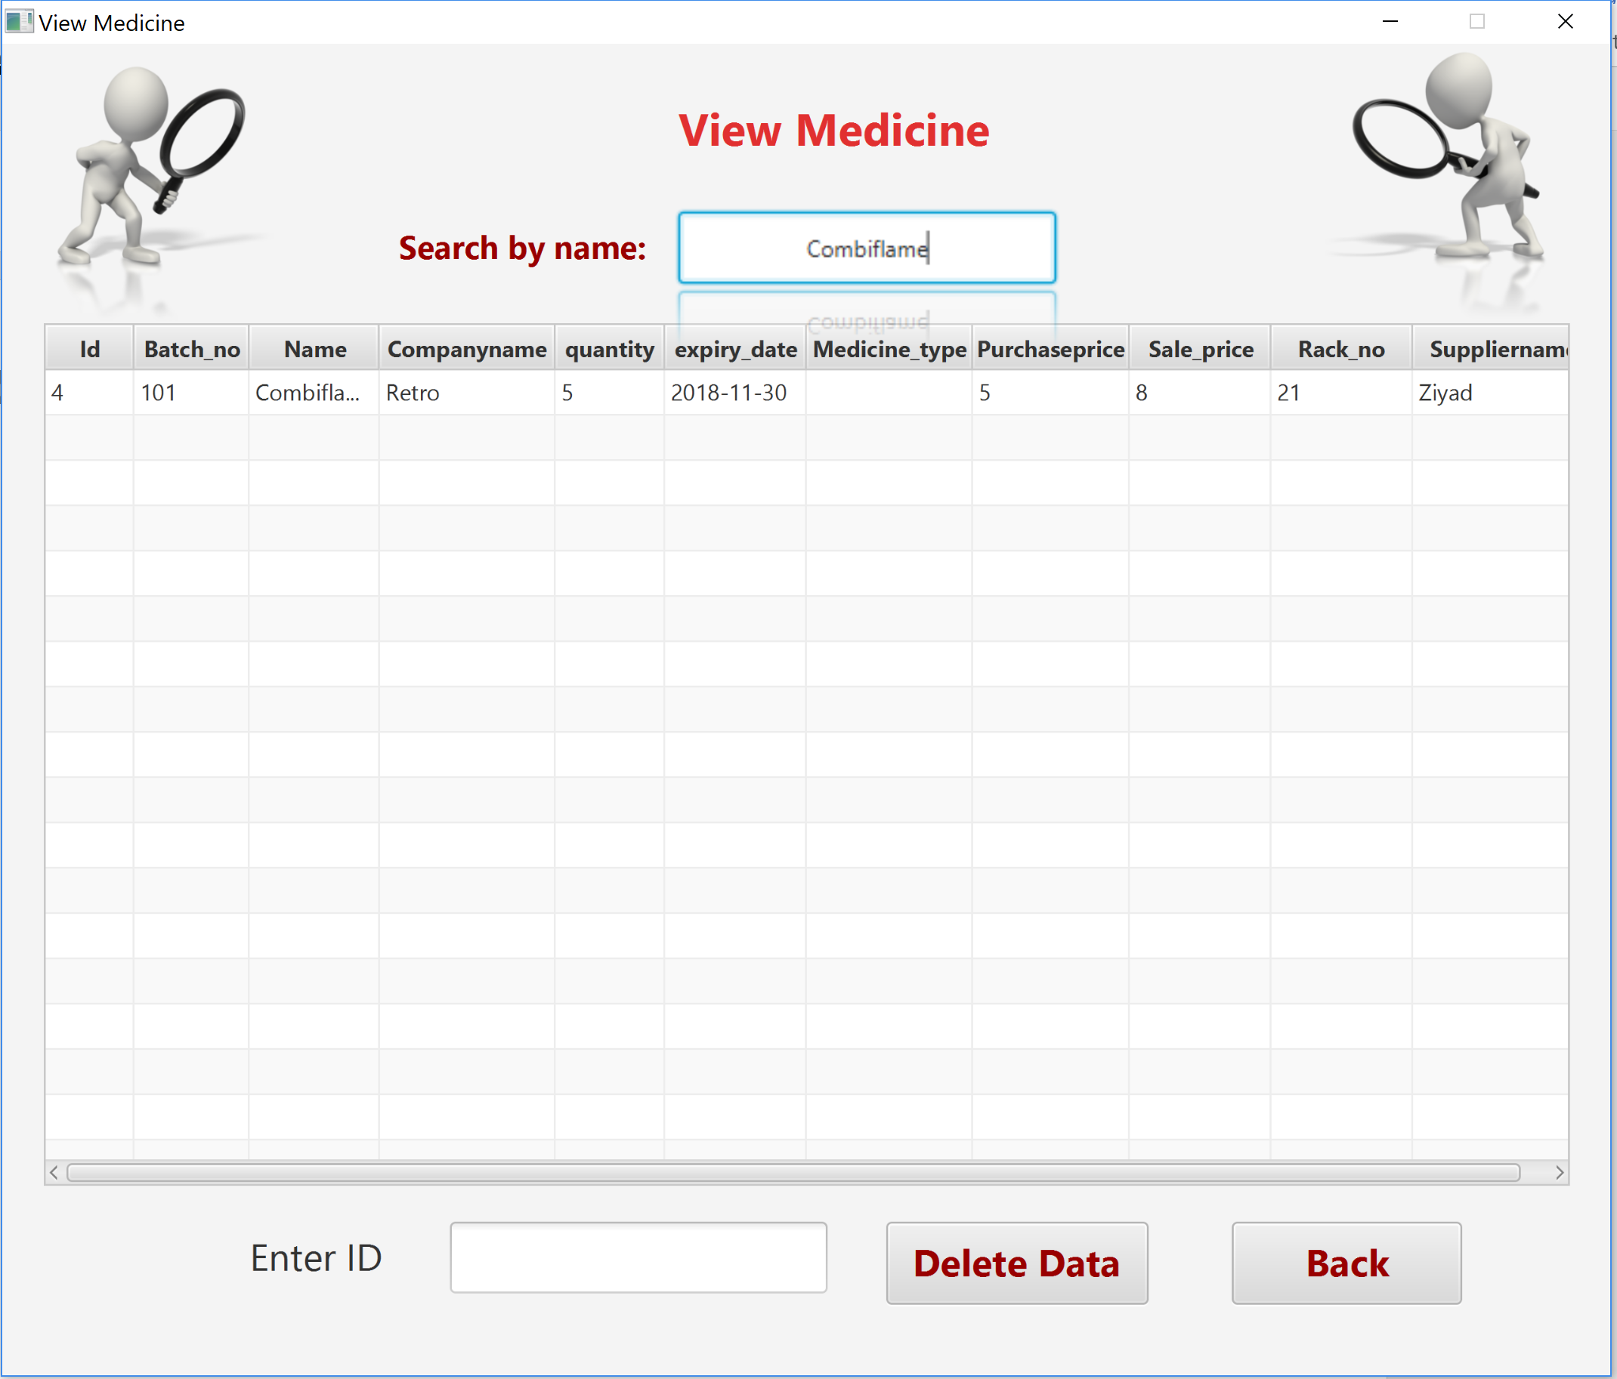

Delete Medicine:

We can delete Medicine By Id.

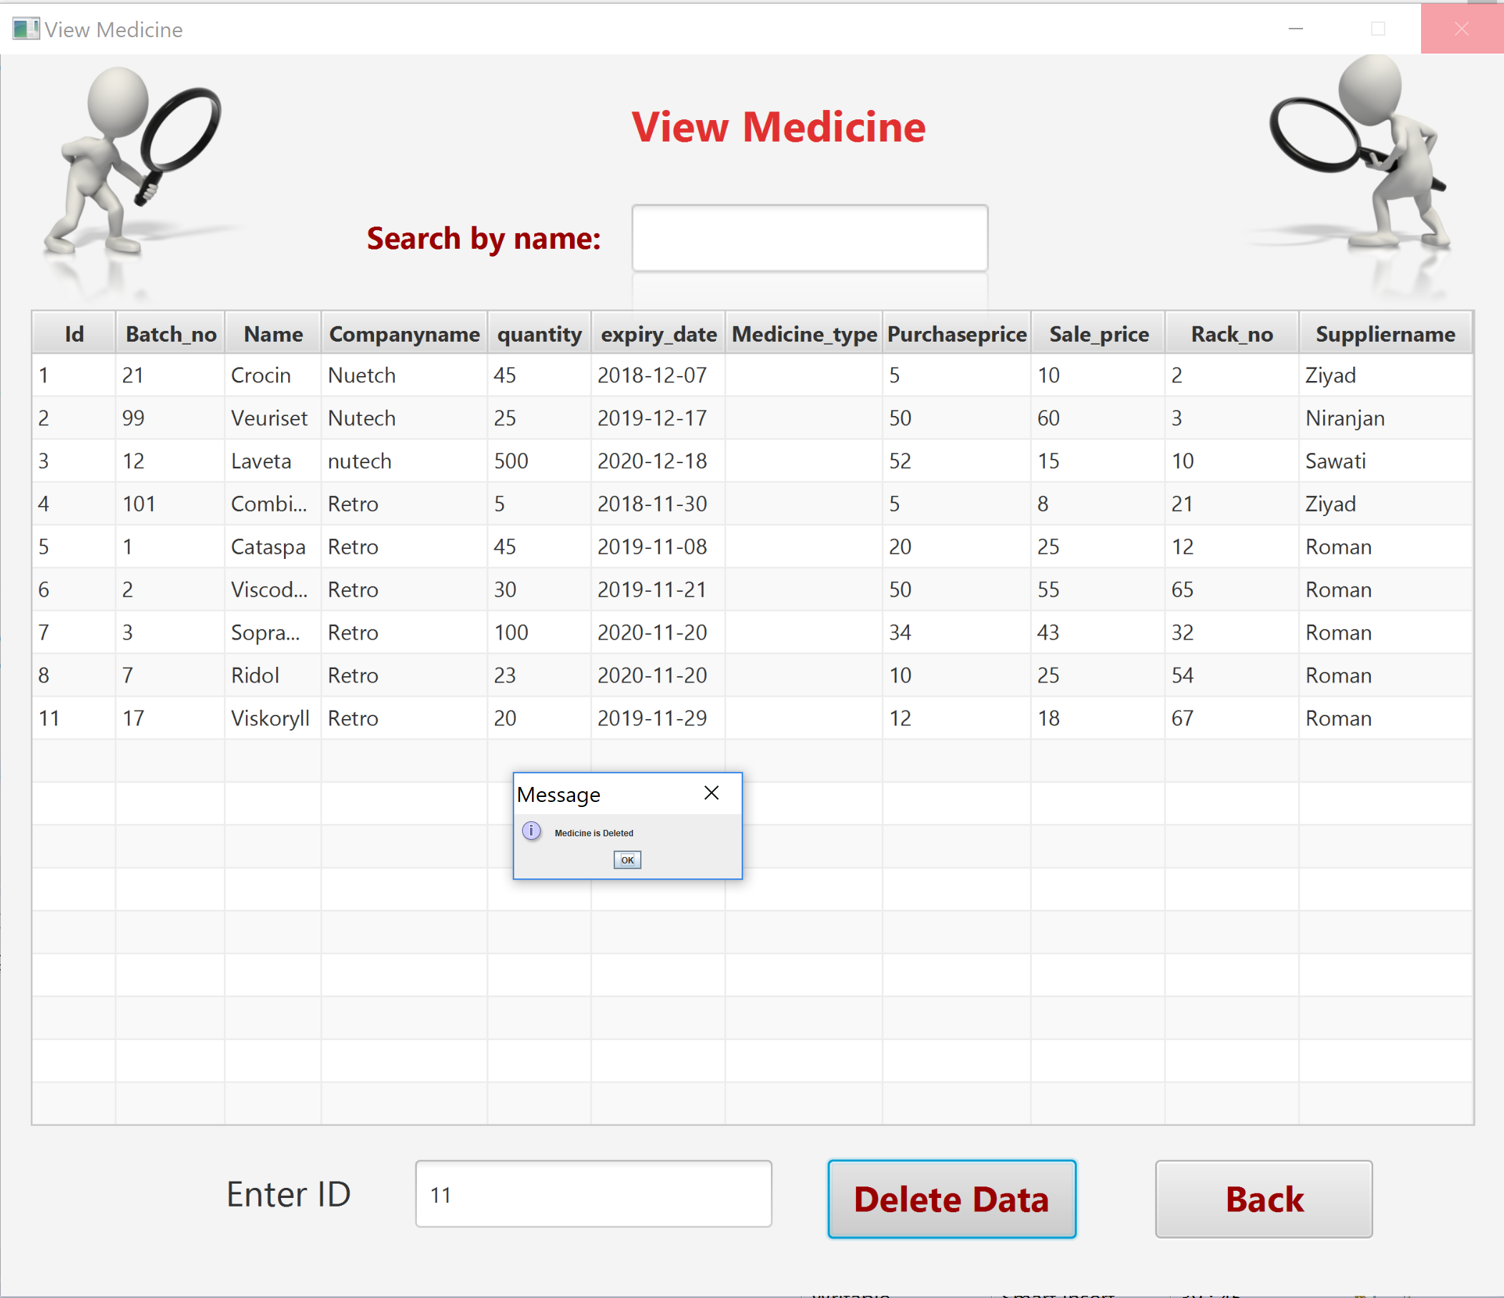

Again Login into admin to generate report



Daily Purchase Report:

We can generate daily report by selecting a date and a store manager.

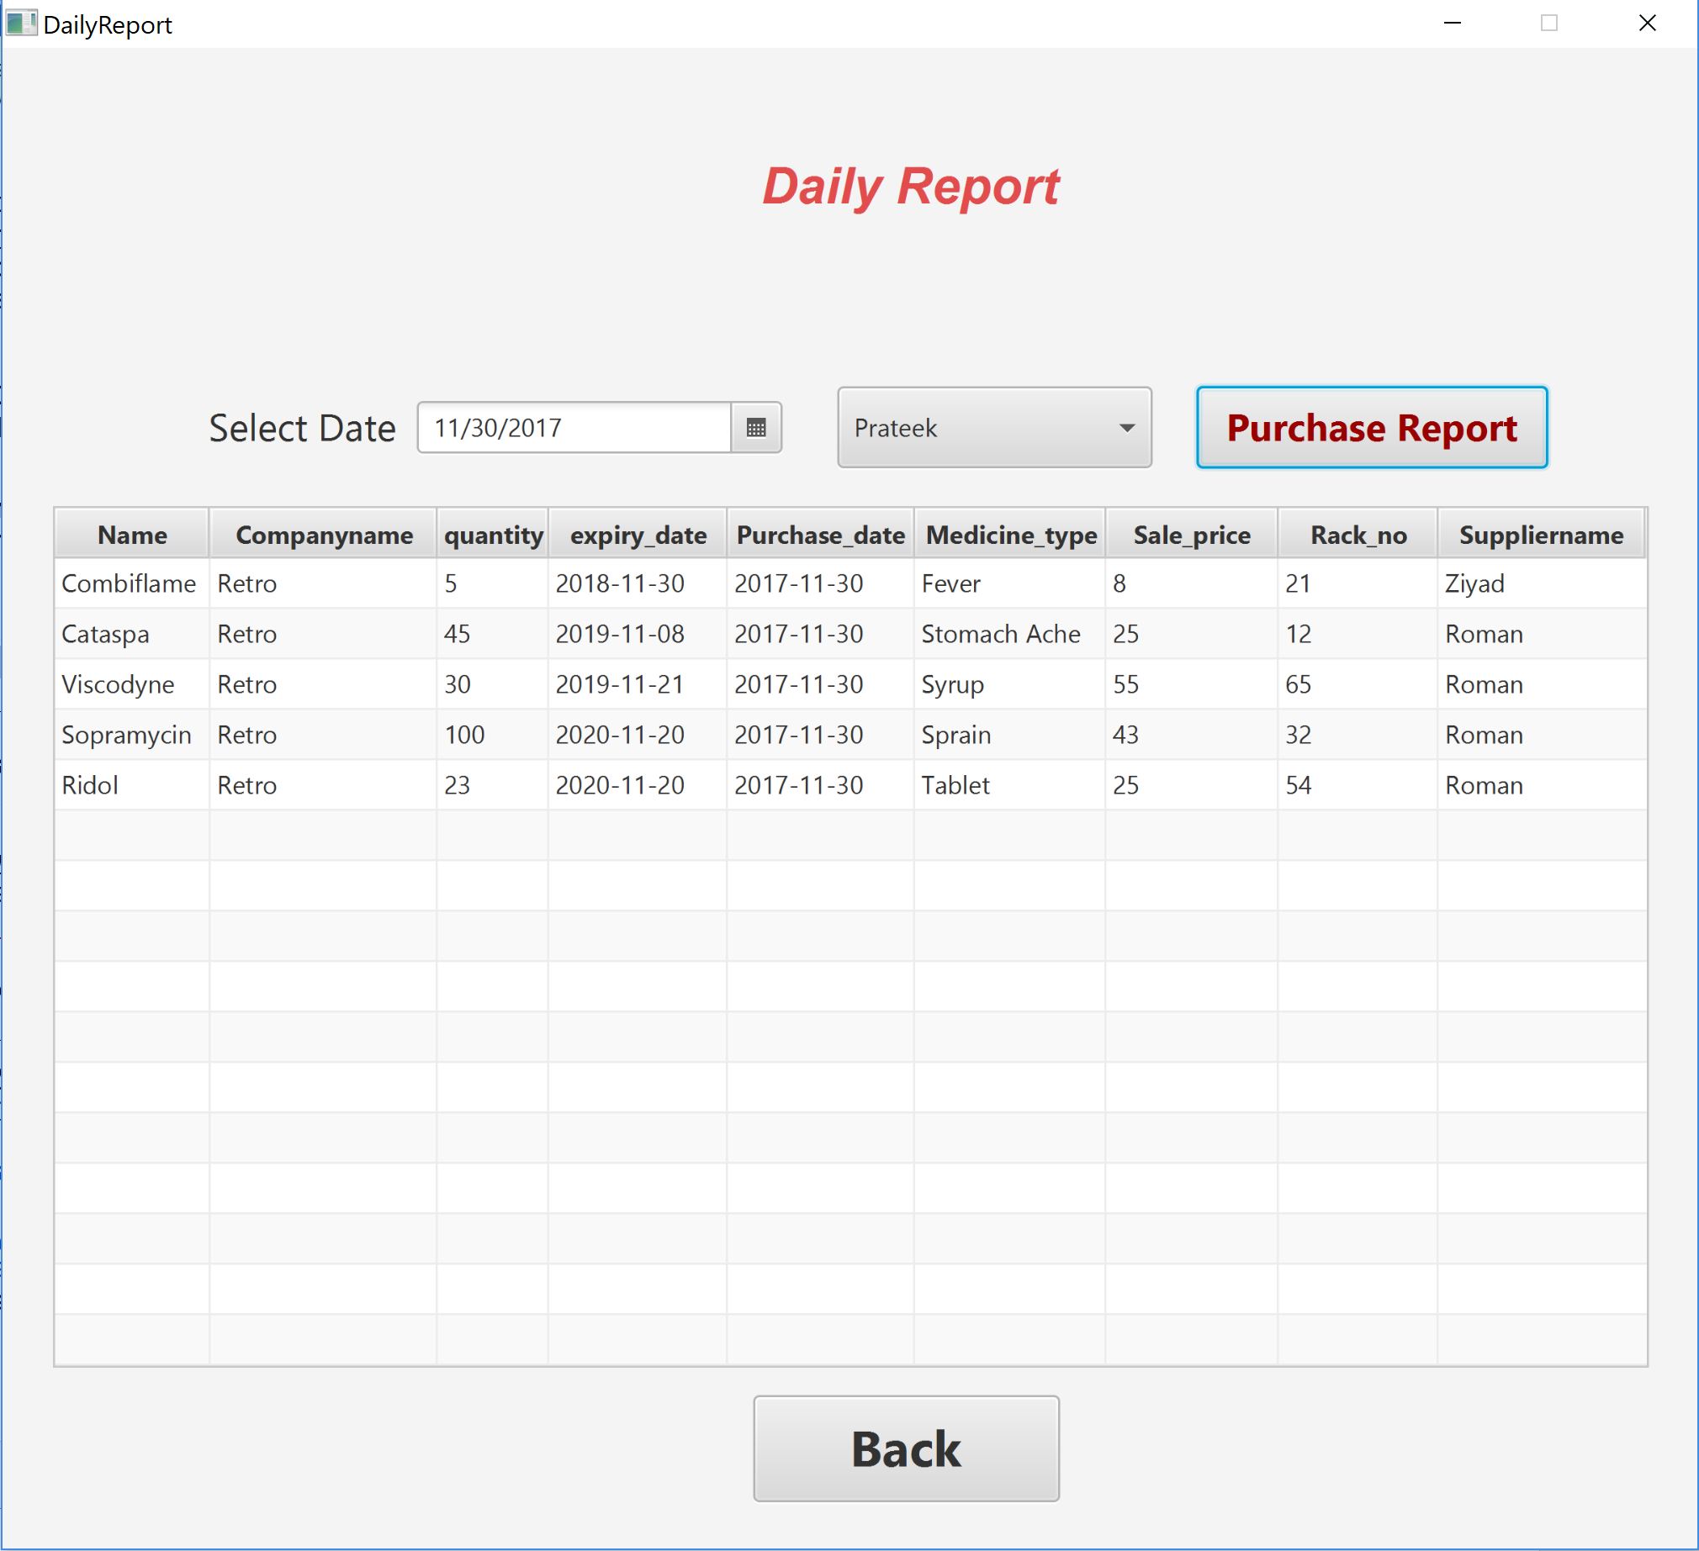

Supplier Wise Report:

We can generate supplier report by selecting a date and a supplier.

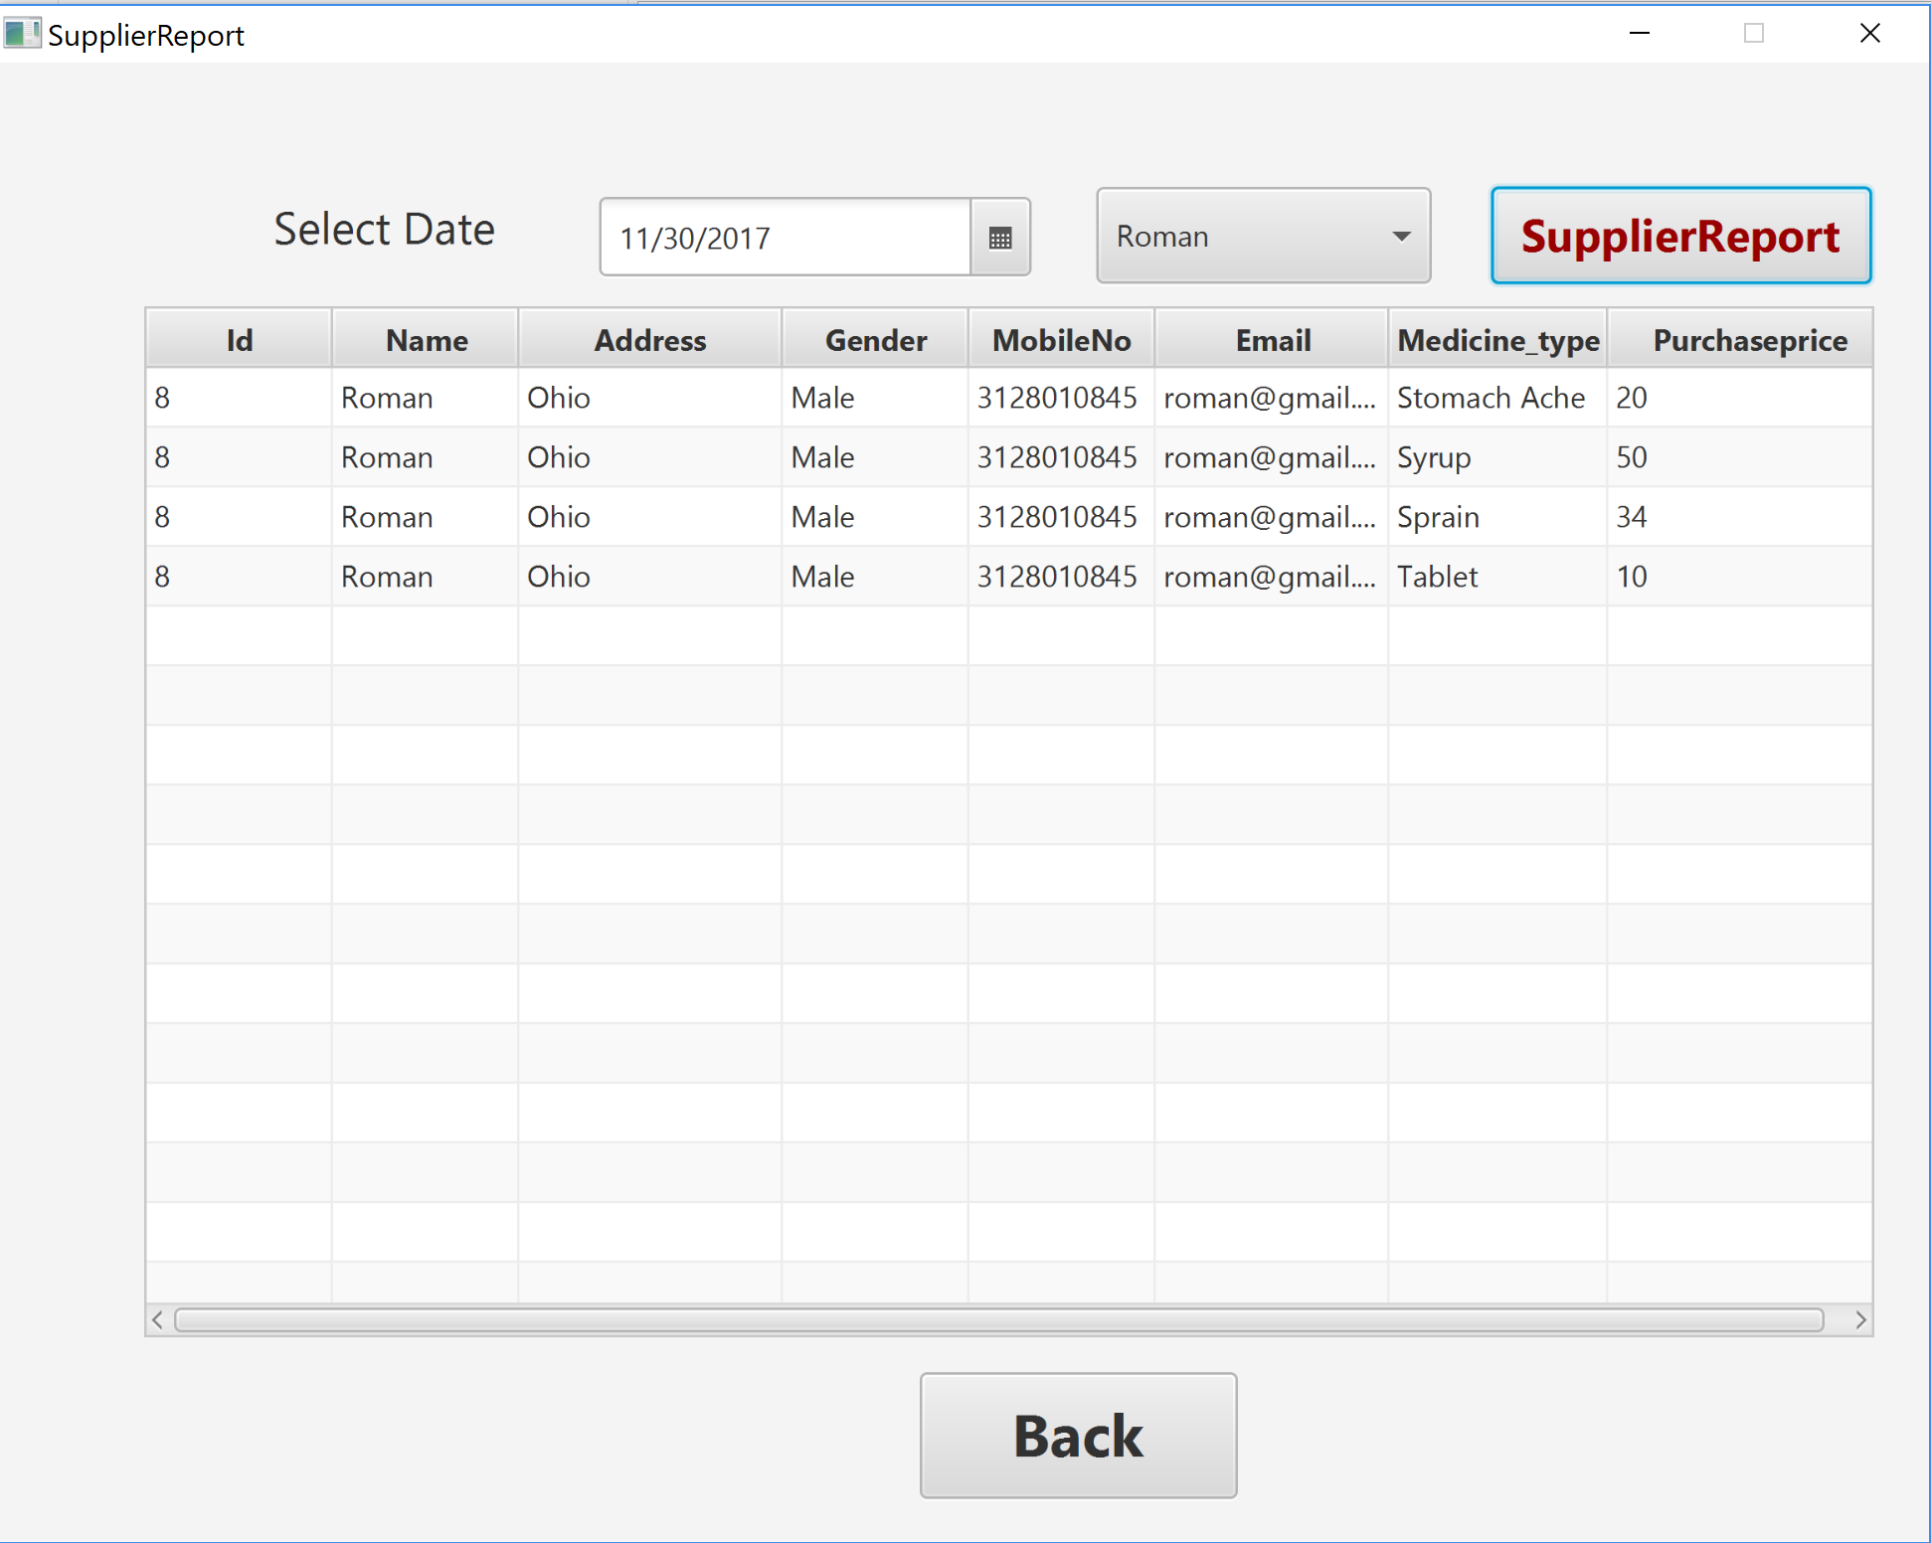

Possible Validation Cases:

1. Should enter all the details

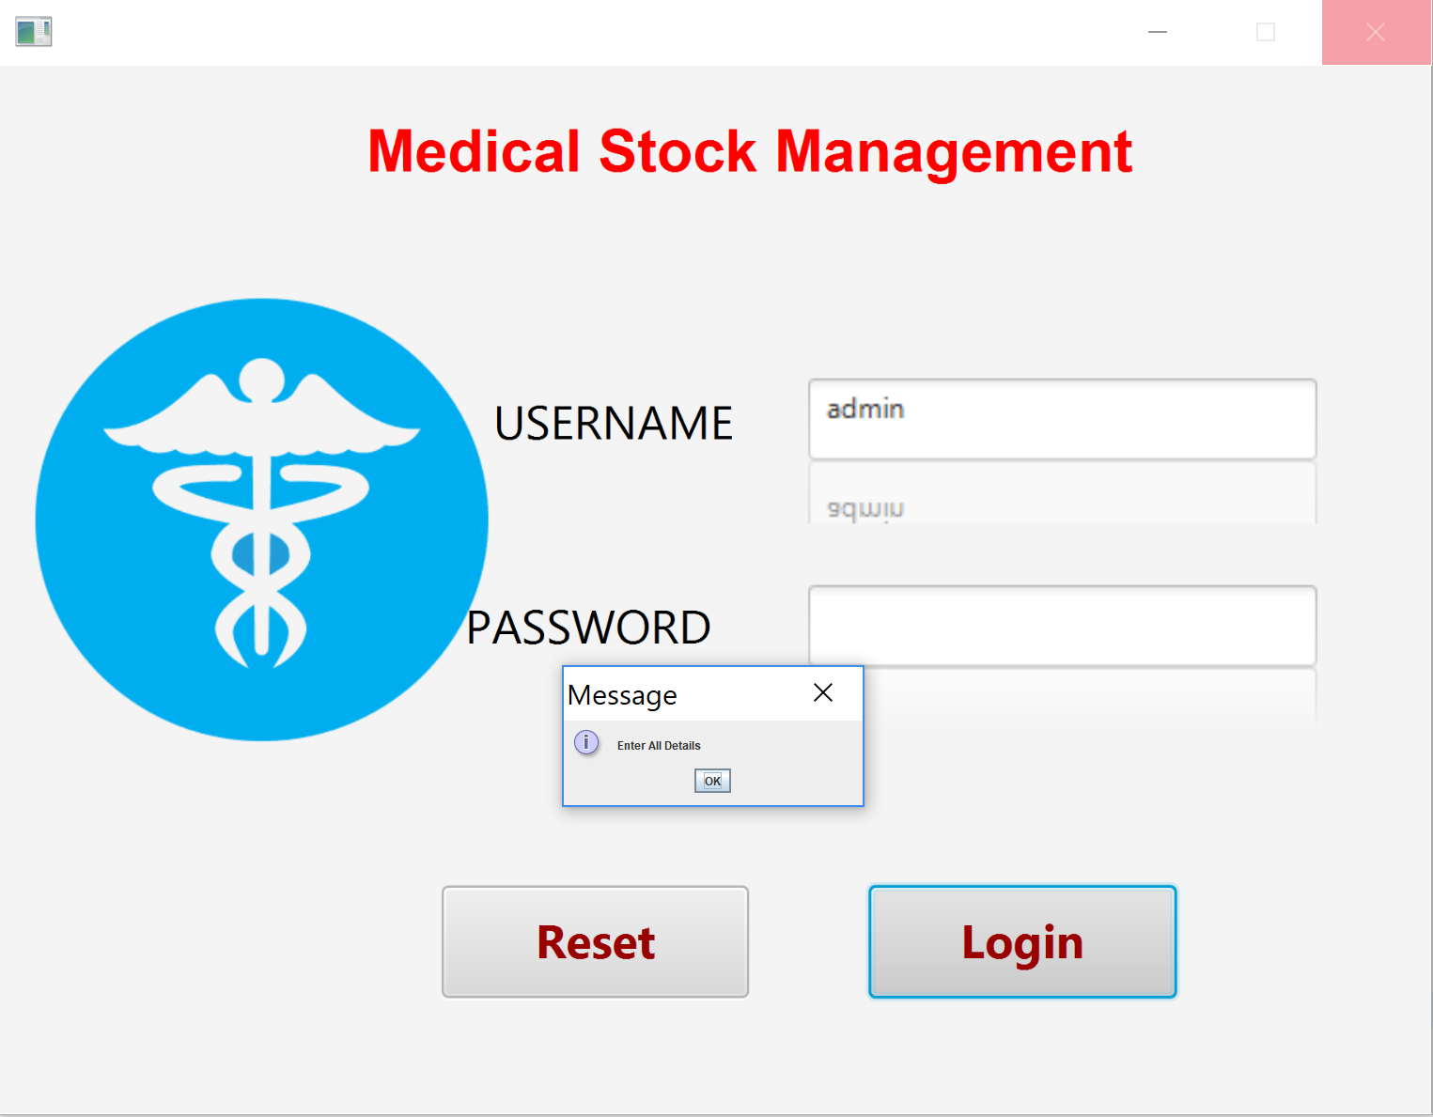

2)Invalid Login Credentials

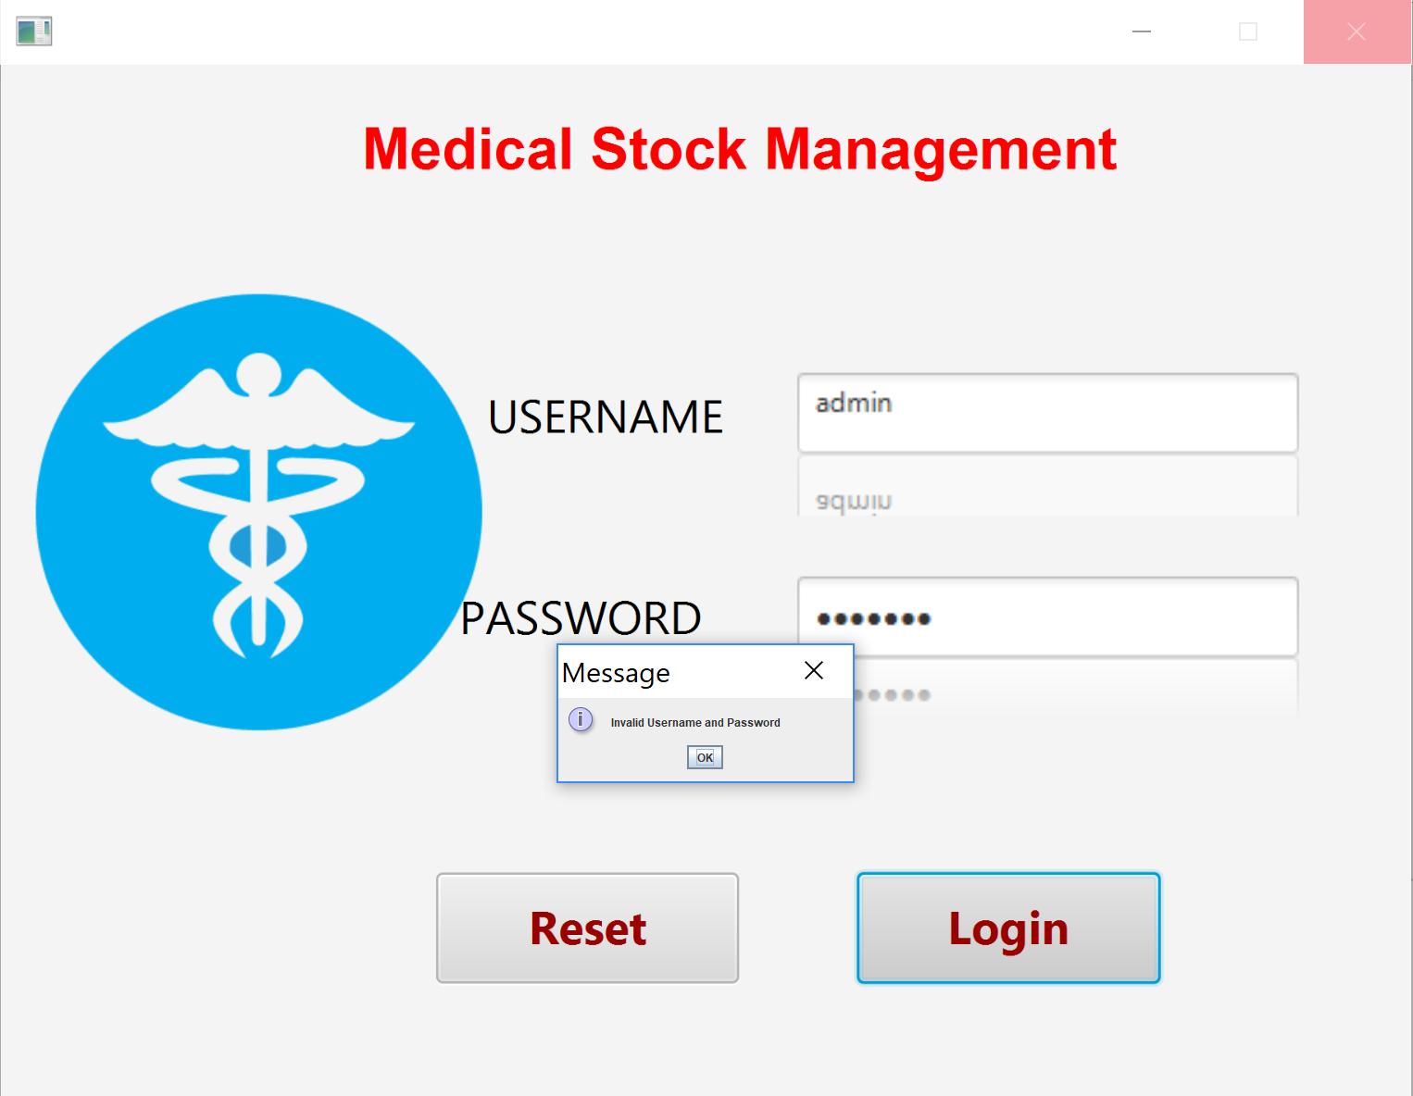

3) Complete all details( Similarly Done for all forms)

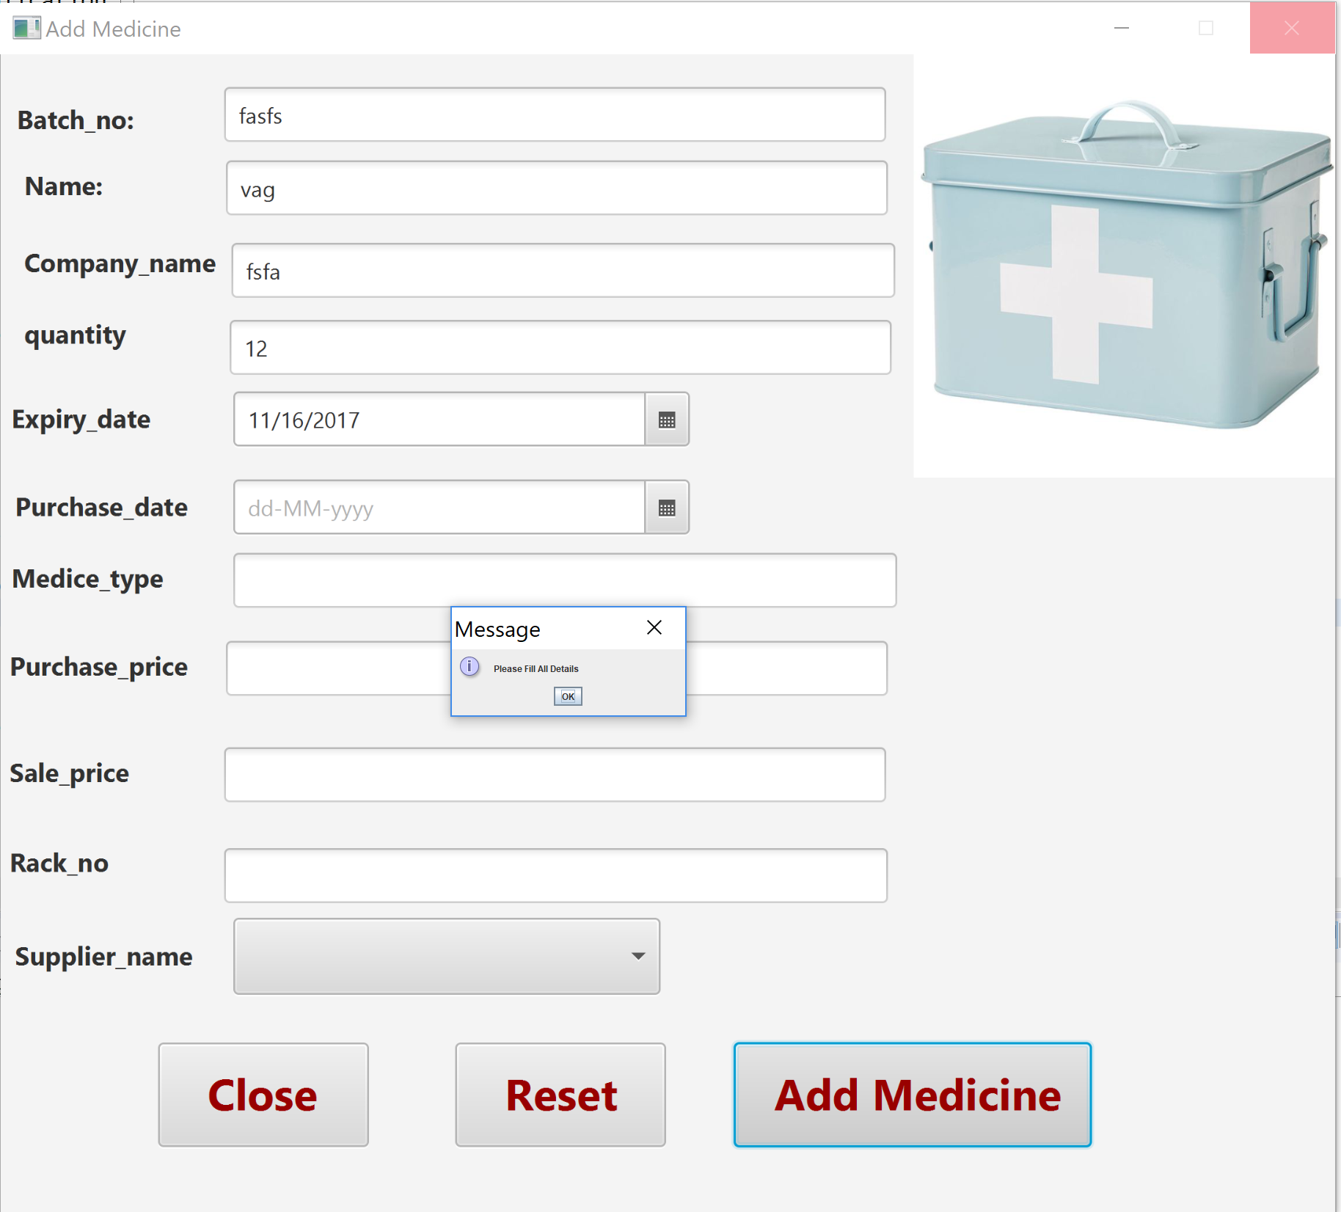

4)Invalid Mobile Number (should be 10 digit Number)

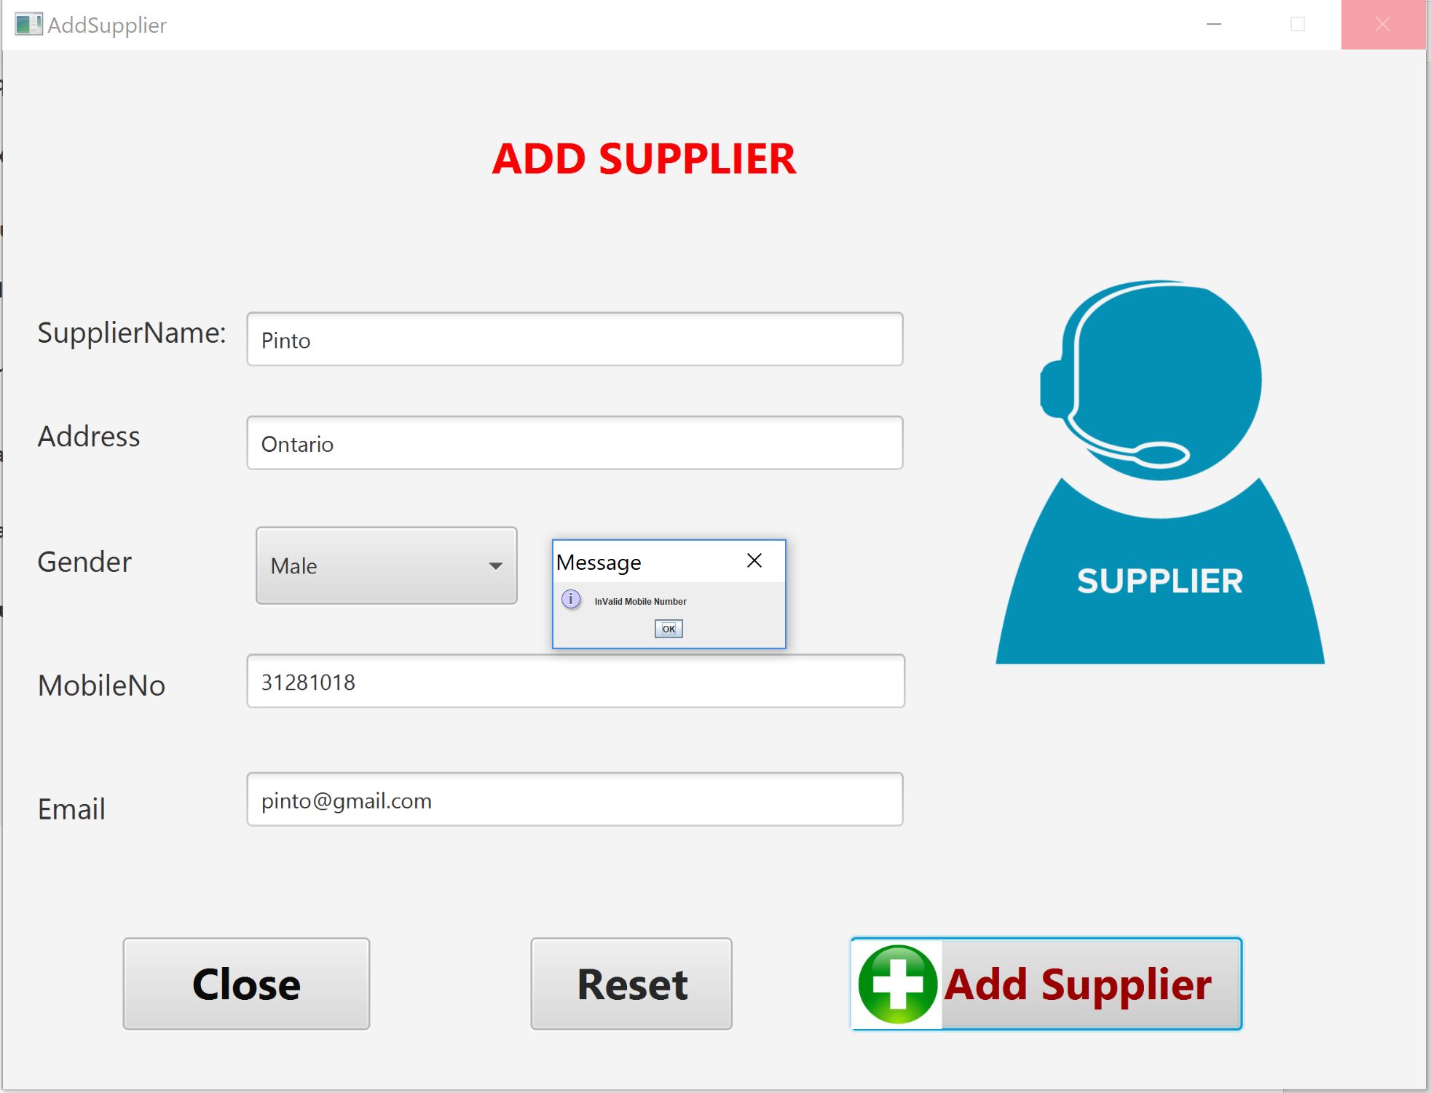

5) Invalid Email (should Contain: - ‘@’ an ‘.(dot)’):

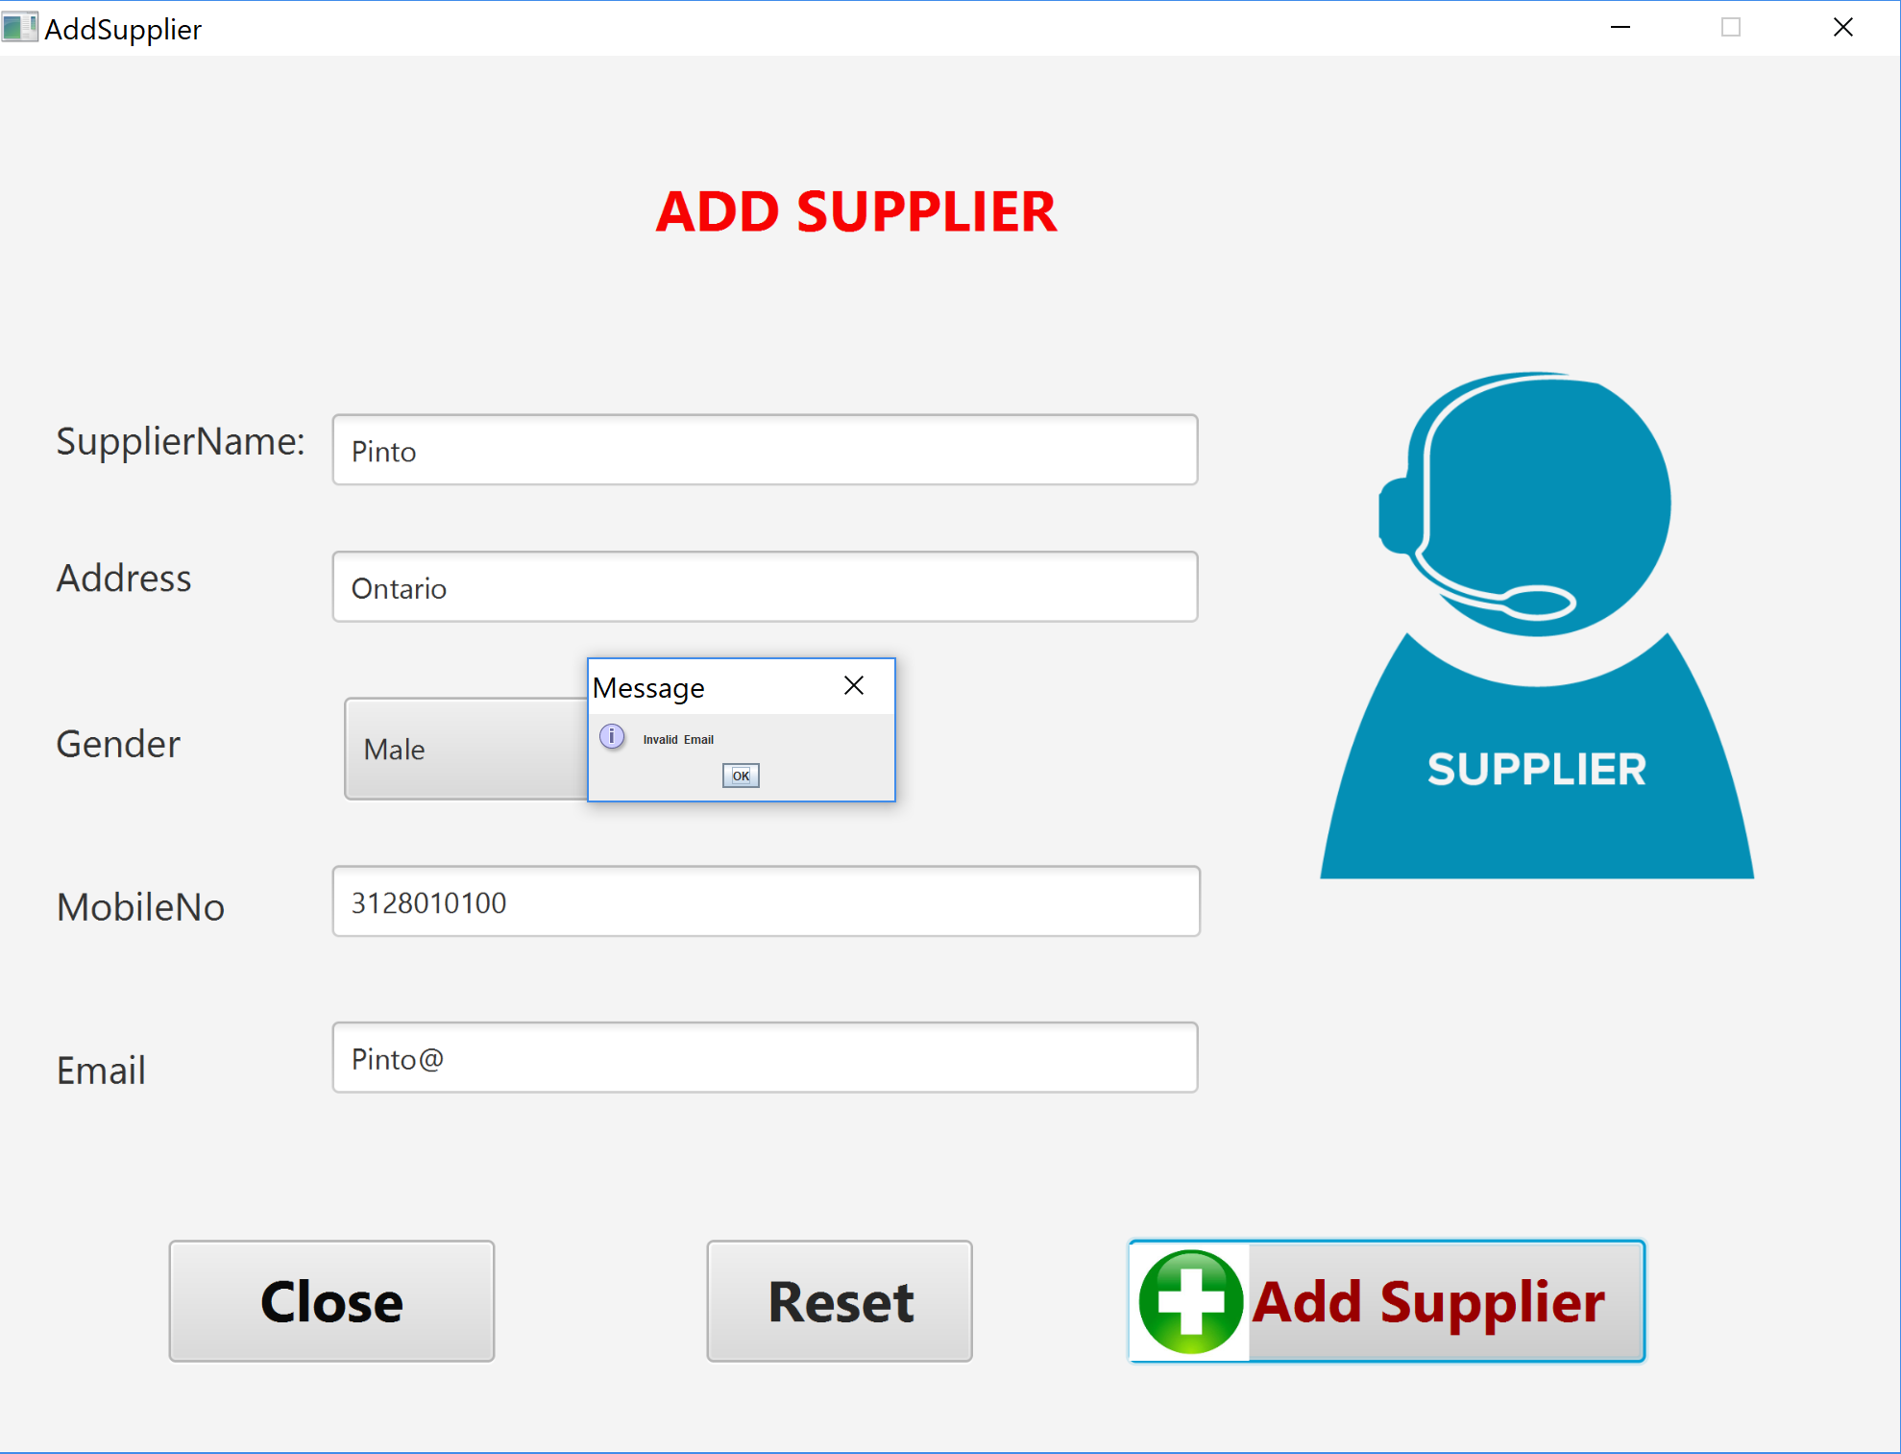

6)To add Medicine We need to select Supplier name, and that supplier should be present in the database

